**Name : Chandana Ramesh Galgali Roll Number : 16010422234 Batch : B-4**

**Tutorial - 8**

**______________________________________________________________________________**

**Code:**

**<!-- HTML -->**

**<!DOCTYPE html>**

**<html>**

**<head>**

**<title>Scent Haven: Your Perfume Destination</title>**

**<style>**

**body {**

**font-family: 'Segoe UI', Tahoma, Geneva, Verdana, sans-serif;**

**color: #3f393f;**

**background-color: #f4effc;**

**margin: 0;**

**padding: 20px;**

**}**

**#featuredperfumes {**

**display: grid;**

**grid-template-columns: 1fr 1fr;**

**grid-gap: 20px;**

**}**

**.featuredperfumes {**

**text-align: center;**

**}**

**h1 {**

**color: #3f393f;**

**text-shadow: 2px 2px 4px #aaa;**

**}**

**h2 {**

**color: #3f393f;**

**border-bottom: 2px solid #3f393f;**

**display: inline-block;**

**margin-top: 20px;**

**}**

**p {**

**color: #3f393f;**

**text-align: justify;**

**}**

**#specialOffer {**

**background: linear-gradient(to right, #8452d4, #ce72ff);**

**-webkit-background-clip: text;**

**background-clip: text;**

**font-size: 22px;**

**margin-top: 20px;**

**}**

**#description {**

**box-shadow: 0 4px 6px rgba(0, 0, 0, 0.1);**

**padding: 15px;**

**border-radius: 8px;**

**background-color: #fff;**

**margin-bottom: 20px;**

**transition: transform 0.3s ease-in-out;**

**}**

**#description:hover {**

**transform: translateY(-5px);**

**}**

**button {**

**background-color: #3f393f;**

**color: #ffffff;**

**border: none;**

**padding: 10px 20px;**

**cursor: pointer;**

**font-size: 16px;**

**border-radius: 20px;**

**box-shadow: 0 2px 4px rgba(0, 0, 0, 0.2);**

**transition: background-color 0.3s ease, transform 0.2s ease-out;**

**}**

**button:hover {**

**background-color: #312e38;**

**transform: scale(1.05);**

**}**

**.slideshow-container {**

**max-width: 350px;**

**margin: auto;**

**position: relative;**

**}**

**.mySlides {**

**display: none;**

**max-width: inherit;**

**}**

**.prev, .next {**

**cursor: pointer;**

**position: absolute;**

**top: 50%;**

**width: auto;**

**padding: 16px;**

**margin-top: -22px;**

**color: white;**

**font-weight: bold;**

**font-size: 18px;**

**transition: 0.6s ease;**

**border-radius: 0 3px 3px 0;**

**user-select: none;**

**background-color: rgba(0, 0, 0, 0.5);**

**text-decoration: none;**

**}**

**.next {**

**right: 0;**

**border-radius: 3px 0 0 3px;**

**}**

**.prev {**

**left: 0;**

**border-radius: 3px 0 0 3px;**

**}**

**.fade {**

**animation-name: fade;**

**animation-duration: 1.5s;**

**}**

**@keyframes fade {**

**from {opacity: .4}**

**to {opacity: 1}**

**}**

**</style>**

**</head>**

**<body>**

**<h1>Welcome to Scent Haven!</h1>**

**<p id="dateDisplay">Discover your perfect scent today.</p>**

**<div id="featuredperfumes">**

**<div id="perfumeNames">**

**<h2>Featured Perfumes</h2>**

**<ul id="arrayDisplay">**

**</ul>**

**</div>**

**<div id="slideshowContainer" class="slideshow-container">**

**<div class="mySlides fade">**

**<img src="rose_oud.jpg" height="400" width="350">**

**</div>**

**<div class="mySlides fade">**

**<img src="jasmine_twilight.jpg" height="400" width="350">**

**</div>**

**<div class="mySlides fade">**

**<img src="citrus_breeze.jpg" height="400" width="350">**

**</div>**

**<div class="mySlides fade">**

**<img src="amber_elegance.jpg" height="400" width="350">**

**</div>**

**<div class="mySlides fade">**

**<img src="vanilla_dreams.jpg" height="400" width="350">**

**</div>**

**<a class="prev" onclick="plusSlides(-1)">&#10094;</a>**

**<a class="next" onclick="plusSlides(1)">&#10095;</a>**

**</div>**

**</div>**

**<h2 id="specialOffer">Special Offer</h2>**

**<p id="description">Click below to reveal our exclusive deal just for you!</p>**

**<button onclick="revealOffer()">Reveal Offer</button>**

**<script src="script.js"></script>**

**</body>**

**</html>**

**// JS**

**const now = new Date();**

**document.getElementById('dateDisplay').innerHTML = `${now.toDateString()}. Discover today's trending perfumes!`;**

**let perfumes = ['Rose & Oud', 'Jasmine Twilight', 'Citrus Breeze', 'Amber Elegance', 'Vanilla Dreams'];**

**let perfumesListHTML = '<ul>';**

**perfumes.forEach(perfume => {**

**perfumesListHTML += `<li>${perfume}</li>`;**

**});**

**perfumesListHTML += '</ul>';**

**document.getElementById('arrayDisplay').innerHTML = `Our Featured Selections: ${perfumesListHTML}`;**

**function revealOffer() {**

**document.getElementById('specialOffer').innerHTML = "Today's Special Offer!";**

**document.getElementById('description').innerHTML = "Enjoy a 20% discount on all first-time purchases. Discover your signature scent with Scent Haven.";**

**document.getElementById('description').style.color = "#007BFF";**

**document.getElementById('description').style.fontWeight = "bold";**

**}**

**let slideIndex = 1;**

**showSlides(slideIndex);**

**function plusSlides(n) {**

**showSlides(slideIndex += n);**

**}**

**function showSlides(n) {**

**let i;**

**let slides = document.getElementsByClassName("mySlides");**

**if (n > slides.length) {slideIndex = 1}**

**if (n < 1) {slideIndex = slides.length}**

**for (i = 0; i < slides.length; i++) {**

**slides[i].style.display = "none";**

**}**

**slides[slideIndex-1].style.display = "block";**

**}**

**______________________________________________________________________________**

**Output:**

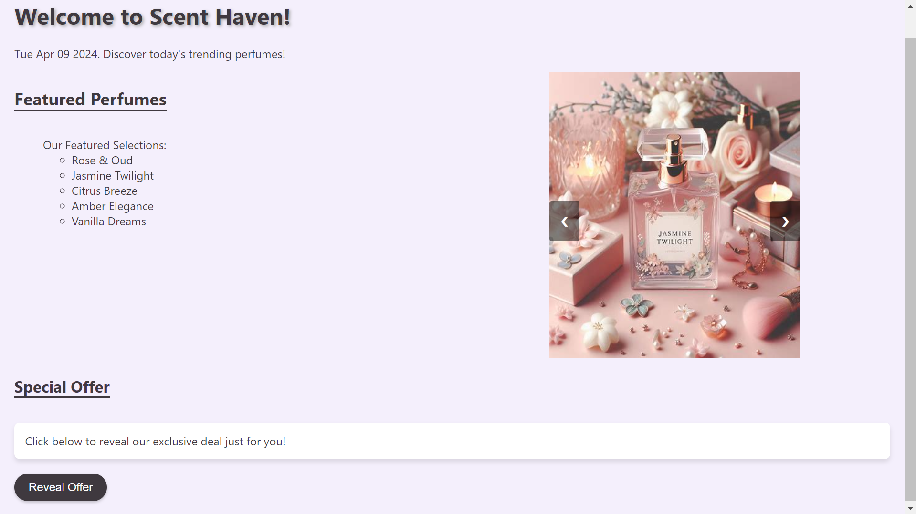

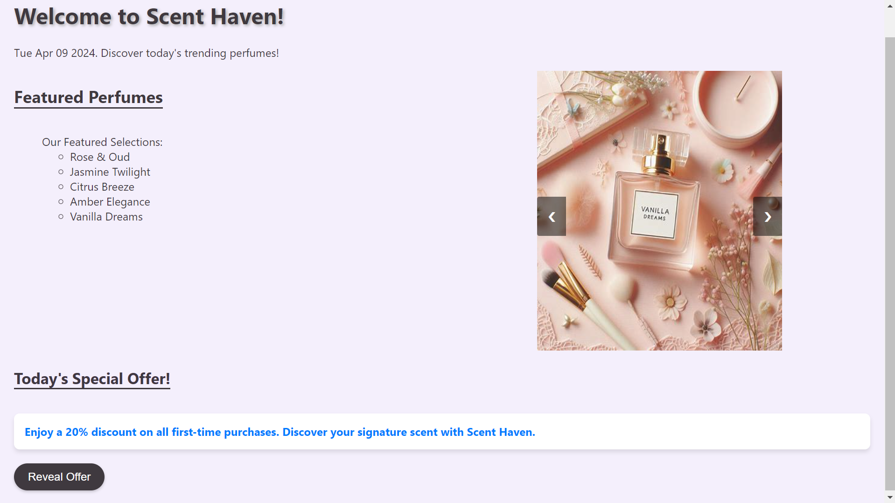

**______________________________________________________________________________**

**Questions:**

**Q1) Explain with examples on how Javascripts help in creating dynamic HTML page.**

**Ans:** JavaScript plays a crucial role in creating dynamic HTML pages by allowing developers to manipulate the Document Object Model (DOM) of a web page. The DOM represents the structure of an HTML document as a tree-like structure, where each element in the HTML document is represented as a node in the tree. JavaScript allows developers to access, modify, and manipulate these nodes dynamically, which in turn allows for the creation of dynamic and interactive web pages.

Here are some examples of how JavaScript helps in creating dynamic HTML pages:

1. Changing HTML Content: JavaScript can be used to dynamically change the content of HTML elements. For example, you can use JavaScript to update the text inside a paragraph or change the attributes of an HTML element based on user actions or other events.

<!DOCTYPE html>

<html>

<head>

<title>Dynamic HTML</title>

<script>

function changeText() {

document.getElementById("demo").innerHTML = "Hello, Dynamic World!";

}

</script>

</head>

<body>

<p id="demo">Hello, World!</p>

<button onclick="changeText()">Change Text</button>

</body>

</html>

2. Manipulating CSS Styles: JavaScript can also be used to dynamically change the CSS styles of HTML elements. This allows for the creation of interactive user interfaces where the appearance of elements can change based on user interactions or other events.

<!DOCTYPE html>

<html>

<head>

<title>Dynamic CSS</title>

<script>

function changeColor() {

document.getElementById("demo").style.color = "red";

}

</script>

</head>

<body>

<p id="demo">Hello, World!</p>

<button onclick="changeColor()">Change Color</button>

</body>

</html>

3. Handling User Events: JavaScript allows developers to define event handlers that respond to user interactions such as clicks, mouse movements, keyboard input, etc. This enables the creation of interactive web applications where actions can trigger responses in real-time.

<!DOCTYPE html>

<html>

<head>

<title>Event Handling</title>

<script>

function showMessage() {

alert("Button clicked!");

}

</script>

</head>

<body>

<button onclick="showMessage()">Click Me</button>

</body>

</html>

These examples illustrate how JavaScript enables the creation of dynamic HTML pages by manipulating the DOM and responding to user interactions.

**Q2) What is DOM? Explain.**

**Ans:** The Document Object Model (DOM) is a programming interface for web documents. It represents the structure of an HTML or XML document as a tree-like structure, where each node in the tree corresponds to a part of the document, such as an element, attribute, or text. The DOM provides a way for programs to dynamically access and manipulate the content, structure, and style of web documents.

In simpler terms, the DOM can be thought of as an API that allows JavaScript (or other scripting languages) to interact with HTML elements. It enables developers to:

Access any element in an HTML document.

Modify the content, structure, and style of HTML elements.

Add or remove HTML elements dynamically.

Respond to user events such as clicks, mouse movements, and keyboard input.

Here's a basic example of how the DOM works:

<html>

<head>

<title>DOM Example</title>

</head>

<body>

<div id="container">

<p>Hello, World!</p>

</div>

<script>

// Accessing an element by its ID

var container = document.getElementById("container");

// Modifying the content of the paragraph element

container.getElementsByTagName("p")[0].innerHTML = "Hello, Dynamic World!";

</script>

</body>

</html>

In this example, JavaScript is used to access the container div element by its ID and then modify the content of the paragraph element inside it. This demonstrates how the DOM allows for the dynamic manipulation of HTML elements using scripting languages like JavaScript.

**______________________________________________________________________________**

**Outcomes:** Apply JavaScript and JSON for Web Application development

**______________________________________________________________________________**

**Conclusion: (Conclusion to be based on the outcomes achieved)**

The experiment effectively demonstrated the power and versatility of JavaScript in manipulating the DOM to create dynamic and engaging web experiences. Participants gained valuable insights and practical skills that can be applied to future web development projects, underscoring the importance of understanding JavaScript for building responsive and interactive web applications.

**______________________________________________________________________________**